(HONORS) GEOMETRY NAME: _______________________
Unit 3 Lesson 4 – Identify Pairs of Lines and Angles BLK: _____ DATE: ____________
Use Parallel Lines and Transversals
Name | Definition | Picture
Parallel lines
Intersecting lines
Perpendicular lines
Oblique lines
Coplanar
Skew |  | 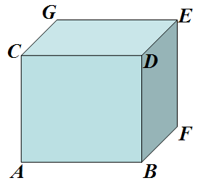

1. Use each of the vocabulary words to describe the picture.
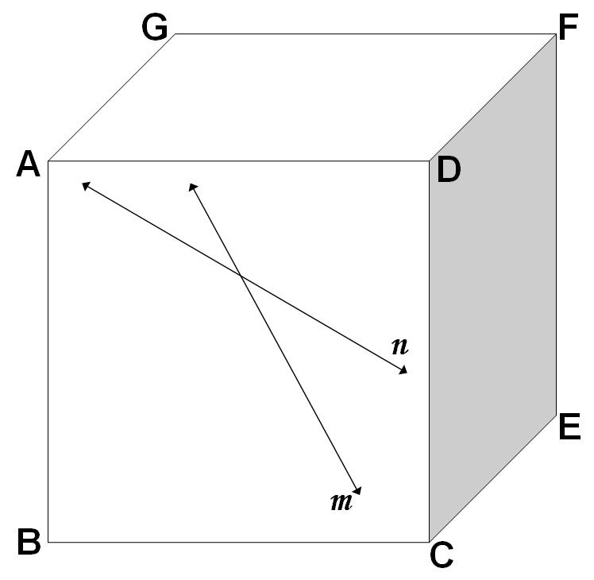
Term | Example
Parallel lines
Intersecting lines
Perpendicular lines
Oblique lines
Coplanar
Skew

Name | Description | Example
Transversal |  | 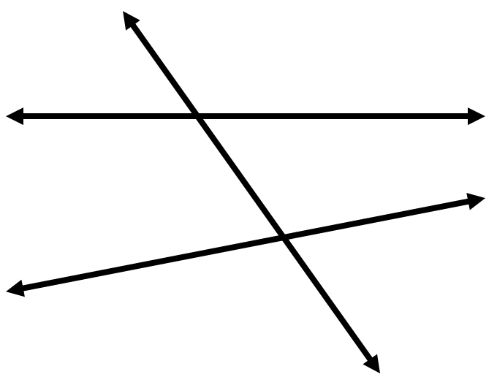
Corresponding Angles
Alternate Interior Angles
Alternate Exterior Angles
Consecutive Interior Angles
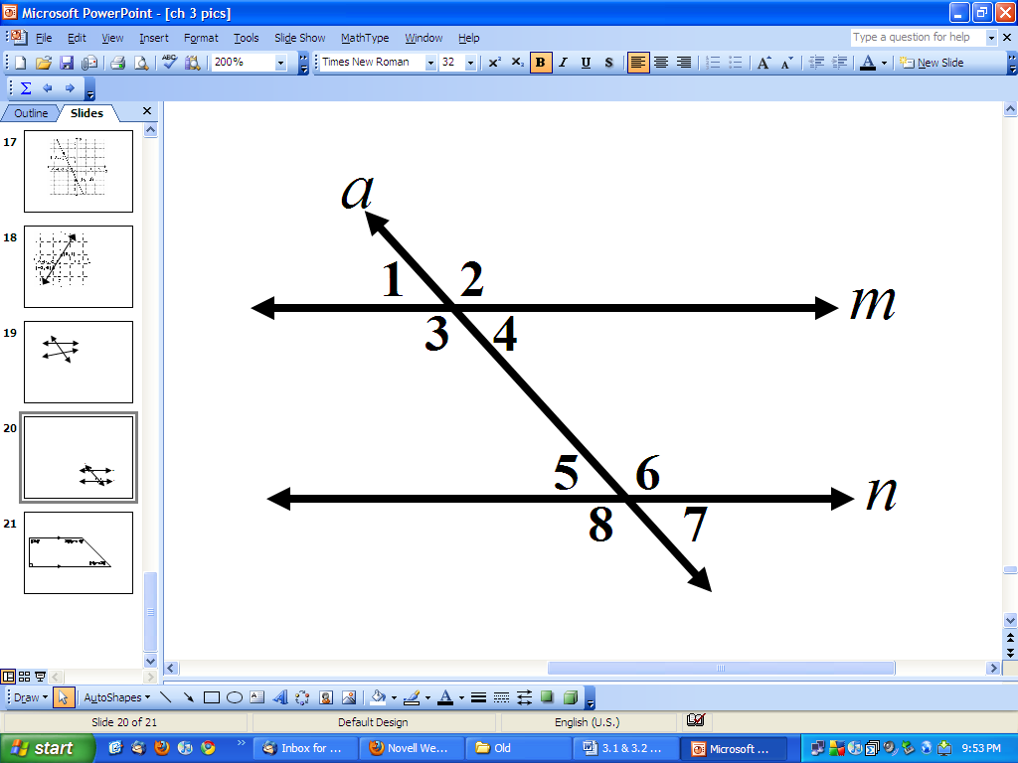
If the two lines are parallel then something magical happens!!!!!!
Corresponding Angles
Alternate Interior Angles
Alternate Exterior Angles
Consecutive Interior Angles

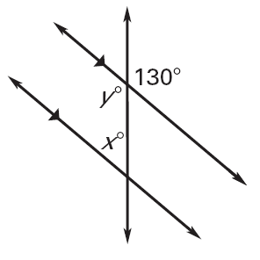
2. Find the missing variables. Explain your reasoning.
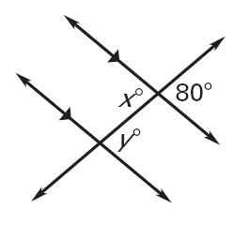
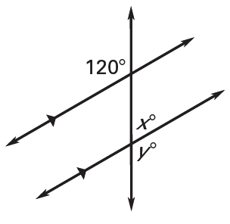

x = __________________________ x = _______________________ x = _______________________

Angle Relationship: ____________ Angle Relationship: ___________ Angle Relationship: ___________

y = __________________________ y = _______________________ y = _______________________

Angle Relationship: ____________ Angle Relationship: ___________ Angle Relationship: ___________

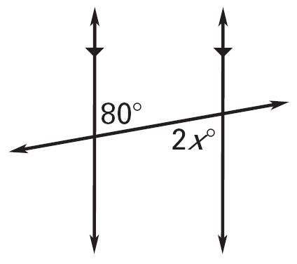
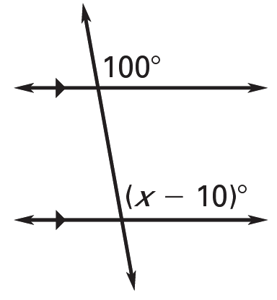
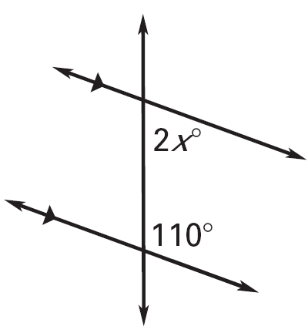

Angle Relationship: ____________ Angle Relationship: ___________ Angle Relationship: ___________

x = __________________________ x = _______________________ x = _______________________

- Solve for x and y. 4. Solve for x and y.
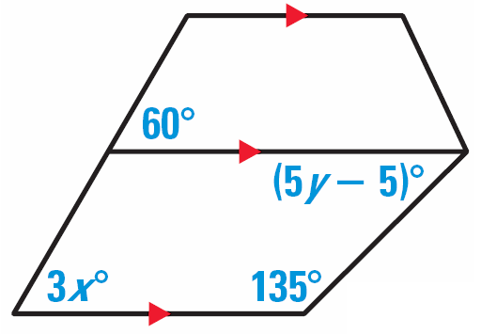
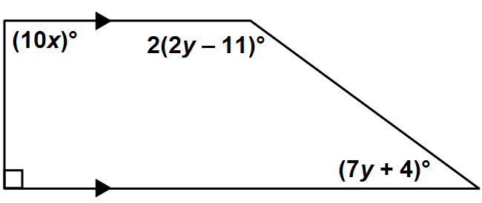

Parallel Postulate

If there is a line and a point not on the line, then there is exactly _____ line
P
through the given point _________________ to the given line.

Perpendicular Postulate

If there is a line and a point not on the line, then there is exactly _____ line
P
through the given point _________________ to the given line.

